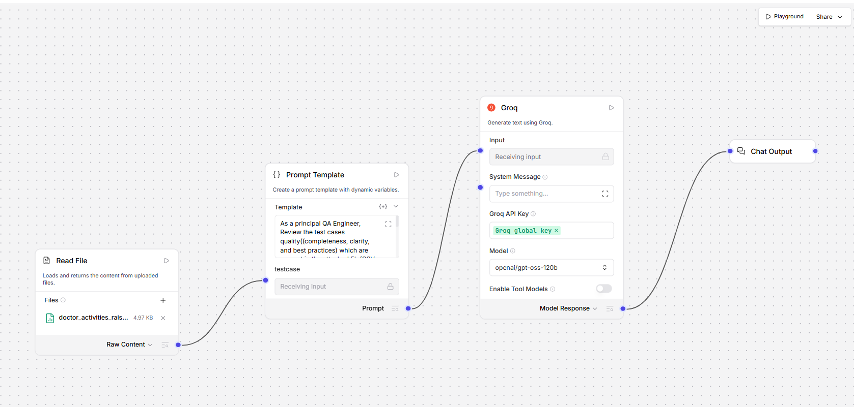

As a principal QA Engineer, Review the test cases quality((completeness, clarity, and best practices) which are present in the attached file(CSV, JSON or in Excel format) and produce the
1. list of issues
2. Any coverage issues
3. Suggestions for improvement
4. An improved vesrion of test case

{testcase}

